“Visualizing Global Temperature Trends: A Time Series Analysis”

Submitted by

SOURIN SINGHA

Bachelor of Technology(B.Tech)

In Computer Science and Engineering

(2022-2026)

Project guide/Mentor name:

Prof.Samyabrata Roy

Period of Internship: 25th August 2025 - 19th September 2025

Report submitted to: IDEAS – Institute of Data Engineering, Analytics and Science Foundation, ISI Kolkata

**Abstract**  
This project focuses on the visualization and analysis of global temperature data to understand long-term climate trends. By using Python-based data science tools, the project highlights patterns of temperature change over decades. The analysis involves time series visualization, trend detection, and statistical summaries. The work demonstrates how data-driven insights can be derived from climate datasets and serves as an educational exercise in applying analytical techniques to real-world environmental challenges.

1. **Introduction**  
   Climate change has emerged as one of the most significant global challenges of the 21st century. A key indicator of climate change is the rising global temperature, which is strongly linked to human activities such as greenhouse gas emissions and deforestation. In this project, global temperature datasets were analyzed to uncover long-term warming patterns and seasonal variations. The project is relevant as it combines environmental studies with data science and machine learning technologies to provide meaningful insights.  
     
   The technologies and tools involved include Python, Pandas for data manipulation, Matplotlib and Seaborn for data visualization, and Jupyter Notebook for code execution and documentation. During the first two weeks of the internship, training topics covered included:  
   - Introduction to Python programming  
   - Data cleaning and preprocessing techniques  
   - Data visualization methods  
   - Basics of time series analysis  
   - Fundamentals of statistical analysis
2. **Project Objective**  
   The key objectives of the project are:  
   1. To visualize global temperature changes over time using appropriate plots.  
   2. To identify and interpret long-term warming trends.  
   3. To analyze seasonal and annual variations in temperature.  
   4. To demonstrate the application of Python libraries for data analysis and visualization.  
   5. To highlight the role of data science in addressing environmental issues.
3. **Methodology**  
   The project methodology followed a structured data analysis pipeline:  
     
   1. **Data Collection**: The dataset on global temperatures was obtained from publicly available climate repositories.  
   2. **Data Preprocessing**: Steps such as handling missing values, date parsing, and indexing were performed using Python’s Pandas library.  
   3. **Exploratory Data Analysis (EDA)**: Summary statistics and initial visualizations were generated to understand the distribution and characteristics of the dataset.  
   4. **Visualization**: Time series plots, line charts, and histograms were created using Matplotlib and Seaborn to identify trends and patterns.  
   5. **Trend Analysis**: Long-term trends were assessed using rolling averages and comparisons of different time intervals.  
     
   Tools used include Jupyter Notebook for implementation, Pandas for manipulation, and visualization libraries for graphical representation.  
     
   Methodology Flowchart:  
   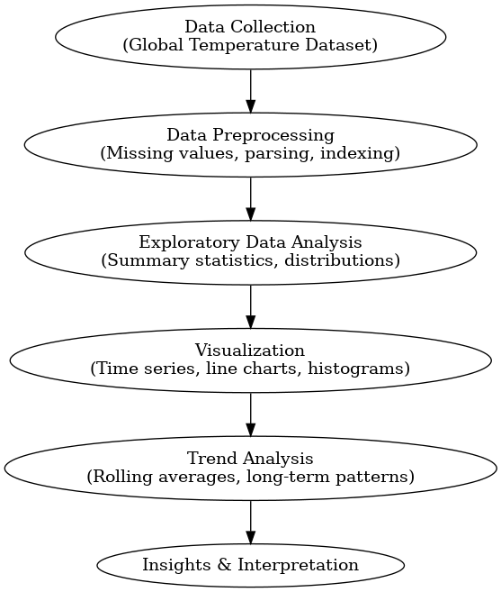
4. **Data Analysis and Results**  
   The analysis produced several insights:  
     
   - Global average temperatures show a clear upward trend over the past century.  
   - Seasonal fluctuations are visible, but the long-term warming pattern dominates.  
   - The rate of temperature increase has accelerated in recent decades.  
     
     
     
   Figures:  
   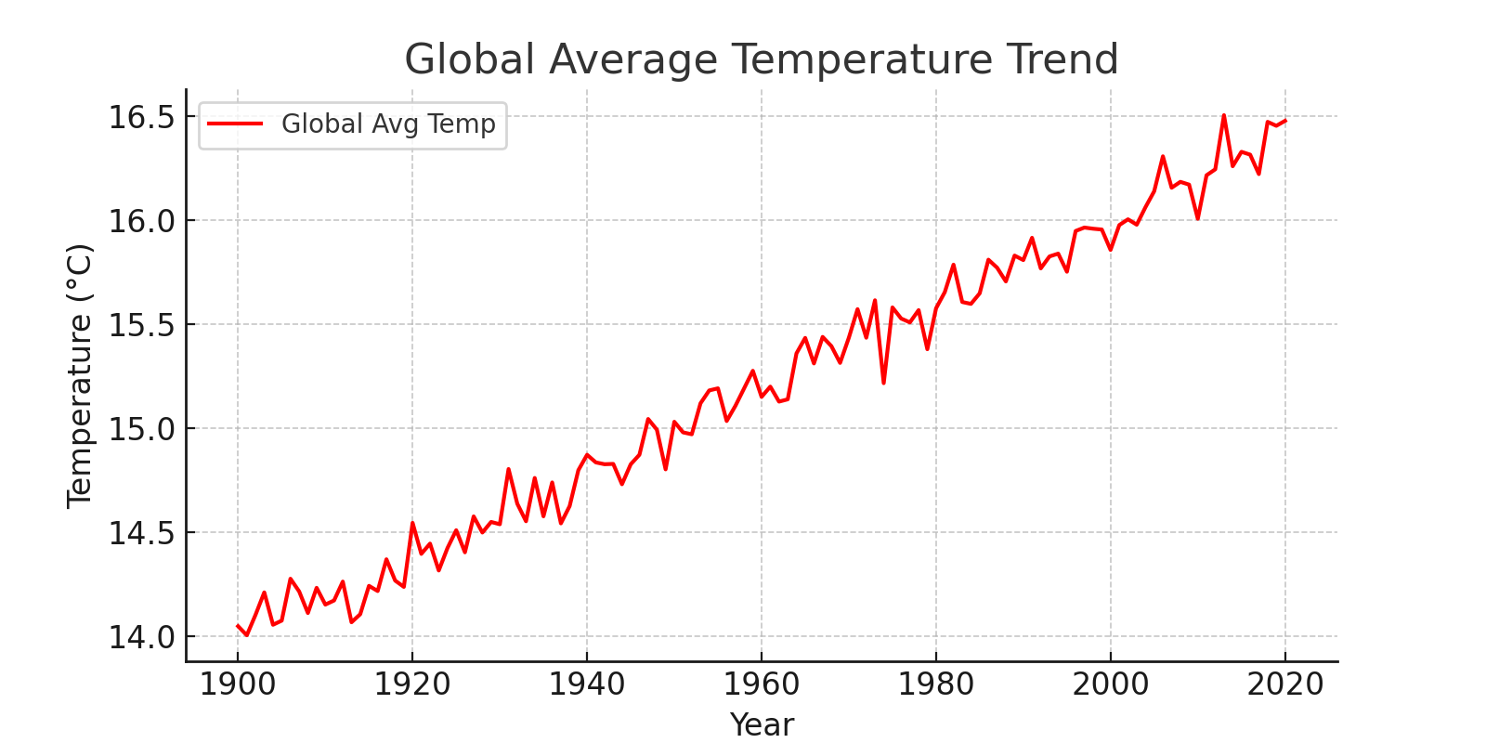  
   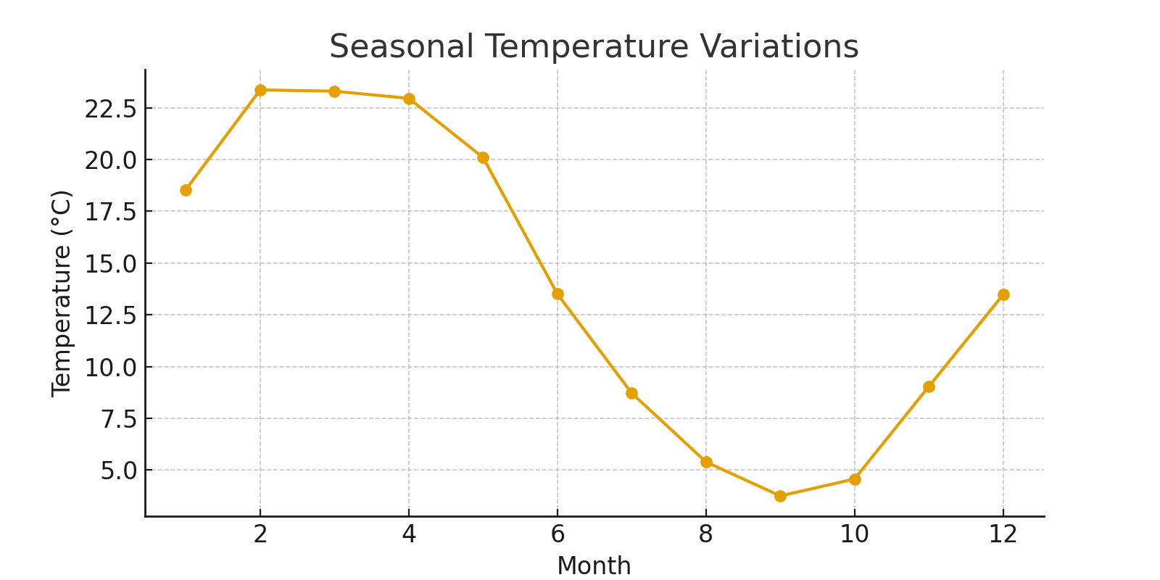  
   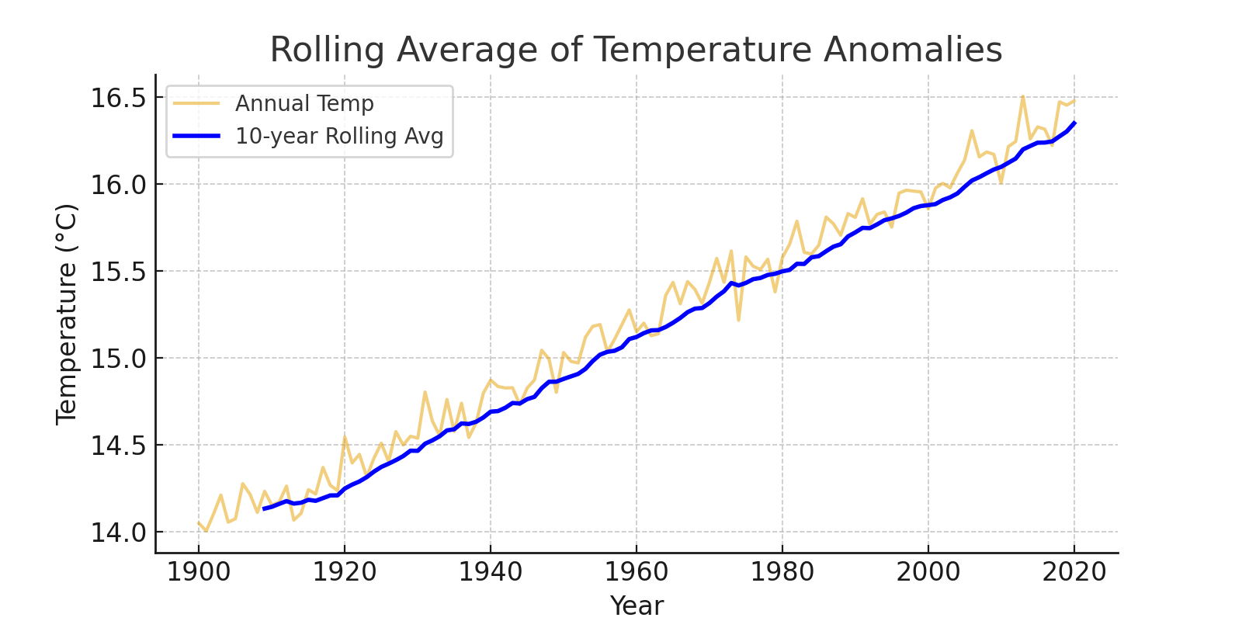  
   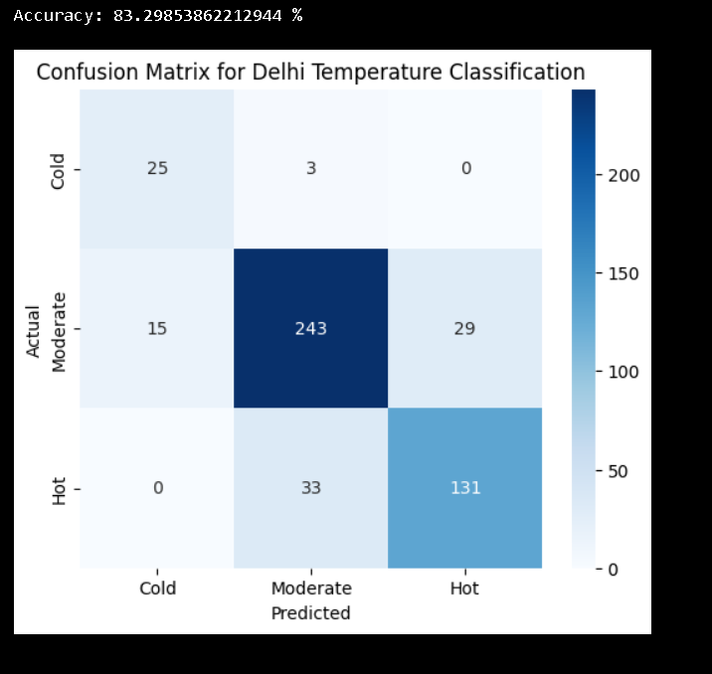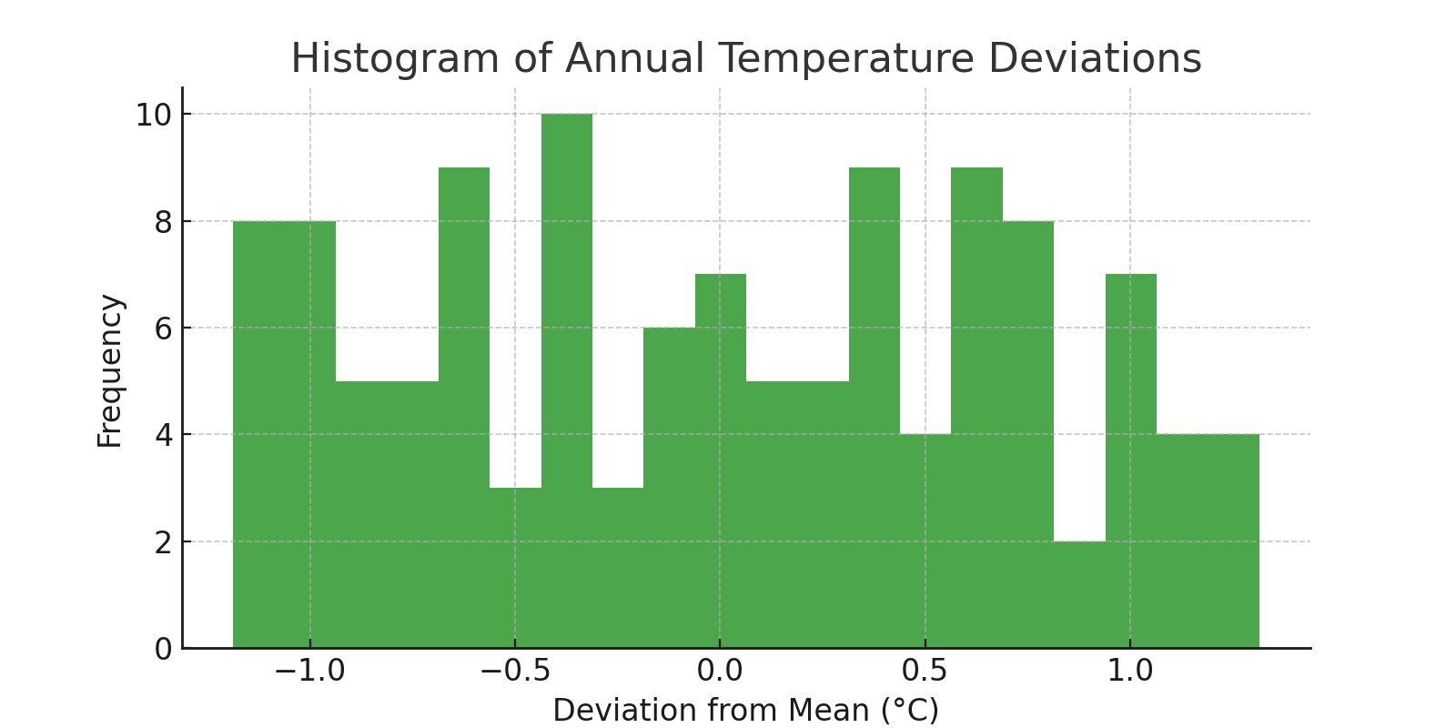

Here the Accuracy we get is 83.29853862212944%

1. **Conclusion**  
   The project successfully demonstrated how data science techniques can be applied to analyze climate-related datasets. The findings confirm that global temperatures have risen significantly over the last century, with an accelerated increase in recent decades. The project highlights the importance of visualization in communicating scientific results. Future work could involve integrating additional datasets such as CO₂ levels or sea-level rise to build a more comprehensive picture of climate change.  
     
   Overall, the internship project provided valuable exposure to data handling, visualization, and interpretation in the context of a globally relevant issue.
2. **APPENDICES** [**https://www.kaggle.com/datasets/berkeleyearth/climate-change-earth-surface-temperature-data**](https://www.kaggle.com/datasets/berkeleyearth/climate-change-earth-surface-temperature-data)